

REQUEST FOR PROPOSAL

Finance Enterprise Resource Planning (ERP) Replacement & Analytics Upgrade

Reference #: [2026]- [02]

Issued: 9/16/2026

Submission Deadline: 10/9/2026

Dear Potential Bidders,

We extend a warm welcome to your participation in our Request for Proposal (RFP) process. Health Plan of San Joaquin and Mountain Valley Health Plan (Health Plan) is seeking qualified vendors to provide Finance Enterprise Resource Planning (ERP) Replacement & Analytics Upgrade. Your expertise and innovative solutions are crucial in helping us achieve our objectives.

This RFP outlines the details of the project, including the scope of work, submission guidelines, and evaluation criteria. We encourage you to carefully review the document and submit a comprehensive proposal that reflects your understanding of our needs and your ability to deliver high-quality results.

Our Mission
“Provide high-quality healthcare for our members through community partnerships”

We value transparency, creativity, and collaboration. Our selection process will be thorough and fair, with an emphasis on finding a partner who shares our commitment to excellence. Your participation in this process is a testament to your dedication to delivering value and contributing to the success of our project.

Thank you for considering Health Plan of San Joaquin for this opportunity. We look forward to receiving your proposals and embarking on a successful collaboration.

Best Regards,

The Procurement Team

Procurement Department
Procurement@hpsj.com
San Joaquin County Health Commission
DBA Health Plan of San Joaquin and Mountain Valley Health Plan

Table of Contents
SECTION I: HEALTH PLAN BACKGROUND 4
A. Health Plan Background 4
B. Statement of Purpose 4
SECTION II: INSTRUCTIONS AND CONDITIONS 4
1. Definitions 4
2. Review and Assessment of Proposal Documents 5
3. Amendments 5
4. Cancellation of RFP 5
5. RFP Schedule 5
6. Procurement Point of Contact 5
7. Questions and Clarifications 6
8. Proposal Submittal 6
9. Pre-Contractual Expenses 6
10. Terms and Conditions 6
11. Eligibility for Contract Award 7
12. Withdrawal of Bids 7
13. Procedures for Handling and Confidential Data 8
14. Evaluation Process 8
15. Award of Contract 10
16. Protest Procedures 11
17. Additional Terms 11
SECTION III – BIDDER INFORMATION 13
1. Vendor Profile (Required with submission) 13
2. References List (Required with submission) 14
3. Local Health Plans of California (LHPC) Relationships (if applicable) 15
4. Security & General Compliance (Required with submission) 16
SECTION IV – TECHNICAL INFORMATION 18
1. Proposed Solution (If Applicable) 18
2. System Architecture, Design, & Hardware Requirements (If Applicable) 19
3. Data Management & Integration (If Applicable) 20
4. Mobility Device & Web Portal Functionality (If Applicable) 22
5. Implementation, Support, & Training (If Applicable) 23
6. Development (If Applicable) 23
7. Business Logic Requirements (If Applicable) 24
TABLE OF ATTACHMENTS 25
ATTACHMENT A - SCOPE OF SERVICES 26
ATTACHMENT B - SCHEDULE OF FEES – Required with Submission 29
ATTACHMENT C – HEALTH PLAN REGULATORY APPROVED CONTRACTING TEMPLATES (Draft SOW Required w/ Submission) 37
ATTACHMENT D – OWNERSHIP AND DISCLOSURE FORM (Required with Submission) 38
ATTACHMENT E - THIRD-PARTY ATTESTATION FORM (May be required at contracting phase) 39
ATTACHMENT F – NON-COLLUSION DECLARATION (Required for Public Works Projects Only) 41
ATTACHMENT G – OFFSHORING QUESTIONAIRRE (Required with Submission) 42
ATTACHMENT H – CONFLICT OF INTEREST (Required with Submission) 43
ATTACHMENT I – BIDDER RESPONSIBILITY AND CERTIFICATION (Required with Submission) 44
ATTACHMENT J – PROPOSAL SIGNATURE VERIFICATION (Required with Submission) 46

SECTION I: HEALTH PLAN BACKGROUND

A. Health Plan Background
Health Plan of San Joaquin (HPSJ) was created in 1996 by the Health Commission to deliver a locally focused Medi-Cal managed care option tailored to the needs of San Joaquin County. In 2013, HPSJ expanded into Stanislaus County, broadening member access through a strengthened, combined provider network.
In 2024, the Health Commission further extended its commitment to community-based care by launching Mountain Valley Health Plan (MVHP) to serve Alpine and El Dorado counties. As of January 1, 2026, Health Plan has launched a Dual Eligible Special Needs Program (DSNP) to provide more coordinated, comprehensive care for individuals who qualify for both Medi-Cal and Medicare. Today, HPSJ and MVHP—collectively known as “Health Plan” serves approximately 400,000 members across its regions.
Additional details regarding the Health Plan are available at the following website: https://www.hpsj.com/

B. Statement of Purpose
This Request for Proposal (RFP) outlines the expectations and required components of the Finance Enterprise Resource Planning (ERP) Replacement & Analytics Upgrade for Health Plan. Through this RFP, Health Plan seeks responses from qualified vendors capable of delivering the services described and meeting all operational, technical, and regulatory obligations associated with this engagement.
For the purposes of this solicitation, a qualified Bidder is defined as an organization with the expertise, capacity, and reliability to provide the requested services for the full duration of the agreement, while meeting the performance standards established by Health Plan and applicable oversight entities.
Recipients of this RFP are expected to review all requirements and priorities carefully. Vendors will have the opportunity to request clarification and submit questions during the designated inquiry period. Final proposals must address all specified needs and include the solutions, services, and supporting elements necessary to fulfill the scope of work. Health Plan will rely on the selected Bidder to ensure technical alignment, system compatibility, and ongoing fulfillment of application and operational requirements throughout the contract term.
Health Plan values long‑term collaboration and seeks to partner with a vendor whose principles, service approach, and organizational character align with Health Plan’s mission. This RFP includes questions regarding Bidder’s background, capabilities, and organizational structure. Please respond thoroughly to each item and include any additional information that would assist Health Plan in its evaluation.

SECTION II: INSTRUCTIONS AND CONDITIONS

1. Definitions
1.1. For the purposes of this document, “RFP” refers to a Request for Proposal.
1.2. “Health Plan” refers to Health Plan of San Joaquin and Mountain Valley Health Plan.

2. Review and Assessment of Proposal Documents
2.1. Bidders are responsible for reviewing all components of this RFP—including the attachments and any subsequent amendments—prior to submitting a proposal. Failure to thoroughly examine the materials does not relieve a Bidder from any obligations should a contract be awarded.
2.2. Each Bidder must independently assess, through review or other means, the conditions and requirements under which the contracted work will be performed.

3. Amendments
Health Plan reserves the right to modify the requirements, deadlines, or other elements of this RFP. Any revisions will be issued as amendments and posted on Health Plan’s website. Health Plan may also notify Bidders who are known recipients of this RFP via email or other appropriate communication channels.
Bidders are expected to acknowledge receipt of all amendments on Attachment J – Proposal Signature Verification.

4. Cancellation of RFP
4.1. The release of this RFP and the receipt of proposals do not obligate Health Plan to award a contract. Health Plan may withdraw the RFP at any time and makes no guarantee that any contract will result from this solicitation.
4.2. Health Plan retains full discretion to postpone the proposal due date; accept or reject any proposal in whole or in part; waive minor irregularities; negotiate with a Bidder other than the initially selected one; negotiate with multiple Bidders simultaneously; or cancel, in full or in part, this RFP without providing justification.

5. RFP Schedule
The table below outlines the planned schedule for this RFP. These dates are provided as the anticipated timeline and may be adjusted at Health Plan’s discretion through a formal amendment. All deadlines will remain in effect as listed unless revised by such an amendment.
RFP Publication Date | Wednesday, 9/16/2026
Proposals Due | Friday, 10/9/2026, by 2:00 PM PST
Short List Established and Contractual Discussions Begin | TBD
* Note: Health Plan may issue a full Security Risk Assessment to selected vendors.

6. Procurement Point of Contact
6.1. All communications concerning this RFP must be directed exclusively to the Health Plan Procurement team via procurement@hpsj.com
6.2. Communication with any other Health Plan staff member, representative, or Commission member regarding this RFP is strictly prohibited. Failure to follow this requirement may result in disqualification from the solicitation.

7. Questions and Clarifications
7.1 Bidders seeking clarification or additional information regarding any part of this RFP must submit their questions in writing. All inquiries should be emailed to procurement@hpsj.com

8. Proposal Submittal
Proposals must be submitted electronically via email to procurement@hpsj.com no later than Friday, 10/9/2026, by 2:00 PM PST. Bidders are encouraged to keep submissions concise and avoid unnecessary promotional content.
Your proposal must be signed by an authorized official of your organization, and the submitted pricing shall remain valid for a period of 180 calendar days beyond the proposal due date.
Response Instructions:
- Answer directly in this document where applicable
- Return completed documents to us electronically via pdf with your company name in the file name.
8.1. Acceptance of Proposal
8.1.1. Health Plan reserves the right to accept or reject any proposal, in whole or in part, and may waive minor informalities or irregularities at its discretion.
8.1.2. Health Plan may withdraw this RFP at any time and makes no guarantee that a contract will result from this solicitation.
8.1.3. Health Plan may postpone the proposal due date or opening for any reason and without prior notice.
8.2. Alternate or substitute proposals are not permitted and will not be reviewed.
8.3. Proposals received after the stated deadline will not be accepted. For the purposes of this RFP, the official submission time is determined by the timestamp on the Health Plan procurement email system.

9. Pre-Contractual Expenses
9.1. All costs associated with preparing and submitting a proposal are the sole responsibility of the Bidder. Under no circumstances will Health Plan reimburse or be held liable for any pre‑contractual expenses. Such costs must not be included in the proposed pricing.

10. Terms and Conditions
10.1. Health Plan will utilize its standard Master Service Agreement (MSA) (Attachment C) as the contractual framework for the selected vendor. The MSA, including the Business Associate Agreement (BAA) and all related exhibits, has been approved by the Department of Health Care Services (DHCS) and the Department of Managed Health Care (DMHC). Because these documents have undergone rigorous regulatory review, respondents are encouraged to limit proposed modifications. Any requested changes must be clearly documented, articulated judiciously, and submitted with the proposal as a separate attachment.
10.2. Bidders must review the MSA in its entirety. If any terms or conditions are unacceptable, the specific sections and proposed alternative language must be identified within the proposal. Failure to disclose requested changes may be considered a waiver of those objections at Health Plan’s discretion.
10.3. Inability or refusal to agree to the MSA may result in the disqualification of the Bidder’s proposal.
10.4. The initial term of the resulting agreement is expected to be three (3) years.

11. Eligibility for Contract Award
11.1. Health Plan will not award a contract under this RFP to any Bidder that is debarred, suspended, or otherwise deemed ineligible to receive federal contracts or to participate in Federal Healthcare Programs. By submitting a proposal, the Bidder affirms and certifies that neither the organization nor any of its officers, directors, owners, partners, or individuals with primary management or supervisory authority are currently debarred, suspended, proposed for debarment, or declared ineligible by any Federal agency, nor excluded from participation in any Federal healthcare program.
11.2. Health Plan prohibits the offshoring of any Health Plan data, including but not limited to Protected Health Information (PHI) or Personally Identifiable Information (PII). Vendors and their subcontractors are not permitted to transmit, access, store, process, or support any Health Plan data from an offshore location. Proposals that include offshoring of Health Plan data will be rejected. Any offshoring of Health Plan data is prohibited unless expressly authorized in writing by Health Plan prior to contract execution.
11.3. Documentation Required with Submission
Bidders must complete and provide the Vendor Profile, References List, Local Health Plans of California Relationships (if applicable), and Security and General Compliance - all found in Section III as part of their proposal submission.
Bidders must complete the below and include the signed documents as part of their proposal submission:
- Attachment B: Schedule of Fees
- Document 02. HPSJ MVHP Exhibit A – Statement of Work (which can be located in Attachment C – Health Plan Regulatory Approved Contracting Templates). A draft Scope of Work must be submitted with your proposal.
- Attachment D: Ownership and Disclosure Form
- Attachment G: Offshoring Questionnaire
- Attachment H: Conflict of Interest Form
- Attachment I: Bidder’s Eligibility
- Attachment J: Proposal Signature Verification (signed with Docusign or similar)

12. Withdrawal of Bids
12.1. A Bidder may withdraw its proposal by submitting a written request via email from an authorized representative who can verify their authority to act on behalf of the Bidder. If the withdrawal is made in person, the individual submitting the withdrawal must acknowledge receipt of the withdrawal at that time.
12.2. Any withdrawal, regardless of the method, must occur prior to the proposal submission deadline specified in this RFP.

13. Procedures for Handling and Confidential Data
13.1. All proposal materials submitted in response to this RFP become the property of Health Plan. Once the Evaluation Committee has completed its review and the Bidder has either (a) been notified that it will not be recommended for award, or (b) the matter has been scheduled for Commission consideration—whichever occurs first—the proposals may be subject to public disclosure. As a public agency, Health Plan is required to comply with the California Public Records Act (Government Code §7920.000 et seq.).
13.2. If Bidder includes proprietary or confidential information, such materials must be clearly marked on each applicable page and easily separable from the non-confidential content to facilitate public inspection. Notwithstanding such designations, certain elements—including pricing, product descriptions, deliverables, and payment terms—are considered public information and will be disclosed regardless of confidentiality markings. Health Plan will make reasonable efforts to restrict internal access to confidential or proprietary information to only those individuals involved in the evaluation process.
13.3. Bidders should be aware that materials marked as confidential may still be subject to disclosure under the Public Records Act. Health Plan discourages the inclusion of unnecessary confidential or proprietary information. If a proposal contains material marked as confidential or proprietary, the proposal must include the following statement:
(legal name of proposer) agrees to indemnify, defend, and hold harmless Health Plan of San Joaquin and Mountain Valley Health Plan, including its officers, agents, and employees, from any claims, actions, or proceedings and any resulting damages or liabilities—including attorney’s fees awarded under the California Public Records Act (Government Code §7920.000 et seq.)—arising from or related to the inclusion, handling, or release of any material designated by (legal name of proposer) as confidential, proprietary, or otherwise exempt from public disclosure.

14. Evaluation Process
Health Plan will evaluate proposals using criteria that consider more than cost alone. Each proposal will be assessed based on Bidder’s experience, demonstrated capabilities, financial stability, overall quality and completeness of the response, and alignment with the requirements of this RFP. Health Plan staff will review all timely submissions in accordance with the criteria described in this section, along with any additional sub‑criteria deemed relevant to the scope of work.
14.2 Demonstrations and Interviews
Following the evaluation of submitted proposals, Health Plan may invite selected vendors to participate in demonstrations and/or interviews. These activities are intended to validate proposal responses, assess solution capabilities, and allow vendors to highlight the strengths of their proposed or services.
14.3. Scoring and Weighting
Health Plan uses a weighted scoring methodology to evaluate proposals. The evaluation categories and associated weightings are as follows; however, Health Plan reserves the right to adjust these percentages based on the specific needs of the business owner for this solicitation.

1. Approach & Methodology – [25] points
Evaluates the vendor’s overall plan to deliver the project, including their technical method, data accuracy controls, innovation, timeline, and ability to produce reliable, high quality outcomes.

Includes:
- Proposed methodology and technical approach
- Data validation, quality assurance process
- Realistic timeline & milestone realism
- Innovation, automation, or workflow improvement

2. Qualifications & Experience – [25] points
Reviews the vendor’s relevant experience, expertise in regulated healthcare, team credentials, staffing capacity, and ability to deliver based on past performance and subject matter knowledge.
Includes:
- Experience with similar health plans or sister plans within publicly regulated healthcare programs
- Team expertise, credentials, and role alignment.
- Experience working with or responding to regulatory bodies (CMS, DHCS/DMHC, state oversight entities)

3. Security, Privacy & Risk Management – [15] points
Measures the vendor’s ability to safeguard PHI, maintain secure data handling, manage system risks, and comply with security, privacy, and retention requirements.
Includes:
- Secure data transfer, access controls, and encryption
- HIPAA compliance, PHI protection, and privacy standards
- Long-term data retention and secure record-management practices

4. [Project Management & Communication] – [10] points
Evaluates the vendor’s ability to manage the project effectively, coordinate stakeholders, maintains clear communication, track issues, and meet deadlines.
Includes:
- Quality and structure of the workplan
- Communication and responsiveness
- issue tracking, escalation process, and cross-department coordination

5. [Interview/Demonstration] – [10] points
Assesses the vendor’s real time clarity, preparedness, subject matter expertise, communication, and alignment with HPSJ’s operational expectations during interviews or demos.
Includes:
- Demonstrated understanding of requirements
- Ability to answer technical, regulatory, and operation questions
- Fit with HPSJ’s collaboration style and culture

6. Cost Proposal, Pricing Transparency & Contract Alignment – [15] points
Evaluates cost clarity and reasonableness.
Includes:
- Transparent base pricing
- Three-year total cost of ownership and pricing predictability
- Clarity of multiyear increases, caps, or price hold commitments
- Acceptance of standard contract templates as-is or with minimal redlines impacting cost or timeline

✔ Scoring Scale (applies to all criteria)
- 5 – Excellent (Exceeds requirements; highly aligned)
- 4 – Good (Meets all requirements; minor gaps)
- 3 – Adequate (Meets most requirements; notable gaps)
- 2 – Weak (Significant weaknesses or risks)
- 1 – Unacceptable (Does not meet requirements)

Proposals will be scored on clarity, depth, and relevance within each category. Health Plan may request clarifications, conduct interviews, evaluate demonstrations, or check references as part of the scoring process.
14.4. Proposals containing false, incomplete, or non‑responsive information may be rejected. Health Plan retains sole discretion to determine whether a proposal has satisfied the requirements of this RFP. Such determinations shall be final.
14.5. At Health Plan, our procurement practices encourage Disabled Veteran’s Business Enterprises, Small, Minority and Women-owned businesses while maintaining competition. All qualified Vendors are encouraged to participate and respond to this RFP.
14.6. Health Plan may give special consideration to Bidders located in, or conducting substantial business within, San Joaquin, Stanislaus, El Dorado, and Alpine Counties.

15. Award of Contract
15.1. Bidders will be notified via email regarding the outcome of the selection process after approval by authorized Health Plan executives. Notification will indicate whether the Bidder has been selected for award.
15.2 Bidders may protest in accordance with Section 18 of this RFP
15.3. Final contract award is subject to approval by the Health Plan Commission and Compliance Audit.
15.4. Compliance Audit
Vendor agrees that, should any pre-delegation or pre-contractual audit be required prior to the selection and execution of a contract, they will fully cooperate and adhere to all requests related to the audit. This includes, but is not limited to, providing access to relevant financial records, operational documentation, and other pertinent information as requested by Health Plan. The Vendor understands that compliance with audit requests is a prerequisite for further consideration and potential contract award.

16. Protest Procedures
A Bidder may formally protest Health Plan’s decision to (a) eliminate the Bidder from further consideration, or (b) award the contract to another Bidder. All protests must meet the requirements outlined below.
16.1. Deadline for Protest
A written protest must be received no later than 5:00 p.m. on the fifth (5th) business day following whichever occurs first:
- Health Plan’s notice of non‑selection, or
- Health Plan’s notice of intent to award the contract.

16.2. Submission Requirements
All protests must be submitted via email to:
procurement@hpsj.com
The written protest must:
- Clearly identify all grounds for the protest;
- Present a detailed explanation of how Health Plan allegedly failed to act reasonably, fairly, or within its discretionary authority;
- Include all supporting documentation the protesting Bidder wishes to have considered.

Health Plan may reject protests lacking sufficient detail or documentation.
16.3. Discretion of Health Plan
Health Plan retains broad discretion to administer and interpret all aspects of this RFP to the fullest extent permitted by law. This RFP shall be construed to preserve such discretion.
Failure to submit a timely and complete protest constitutes a waiver of any right to challenge the award, including through legal action. Untimely protests will not be reviewed.
16.4. Effect of a Protest
Health Plan may proceed with contract award and implementation while a protest is pending, at its sole discretion.

17. Additional Terms
17.1. The selected Bidder may not assign the contract or any portion of its obligations without prior written approval from Health Plan. Health Plan may withhold such approval at its discretion.
17.2. The successful Bidder will be required to enter into Health Plan’s Master Services Agreement.
17.3. Bidders acknowledge that Medi‑Cal Managed Care and Dual Special Needs Programs operate in a dynamic regulatory environment. The successful Bidder must be prepared to implement changes to processes, services, or system requirements as needed to remain compliant with evolving state and federal mandates.
17.4. The resulting contract(s) may, with prior written approval from Health Plan, be made available for use by other California Medi‑Cal managed care plans or public agencies. Any such use will require mutual agreement between the awarded vendor and the participating entity.
Participating entities will be responsible for executing their own agreements and for ensuring compliance with all applicable legal, regulatory, and operational requirements. Health Plan assumes no liability or responsibility for the use of the contract by any other entity.
Any participating entity utilizing the resulting contract must independently ensure adherence to all applicable requirements of the California Department of Health Care Services (DHCS), as well as any federal, state, or local regulations governing Medi‑Cal managed care.
17.5. Notice of Additional Information Required from Finalist(s)
Please be advised, if selected as the finalist in the Finance Enterprise Resource Planning (ERP) Replacement & Analytics Upgrade RFP, your organization may be required to provide some or all of the following additional items to facilitate a thorough evaluation and ensure compliance with our standards:

Current W-9 Form - Signed within 6 months.
Certificates of Insurance – As applicable
Disaster Recovery Plan - A comprehensive disaster recovery plan outlining how your organization will maintain continuity of services in the event of a disaster. This plan should include details on data backup, system redundancy, recovery time objectives (RTOs), recovery point objectives (RPOs), and any emergency communication protocols.
Financials - Prior 3 fiscal years of complete set of audited financial statements (Income Statement, Balance Sheet, Statement of Cashflows, foot note disclosures, and tax returns).
Internal Controls - Prior 3 fiscal years of audit of internal controls (SOC 1 Report)
HITRUST Validated Report to provide assurance of your security posture.
Compliance Documentation - Documentation that demonstrates your compliance with all applicable federal and state regulations. This documentation should include proof of licensing, certifications, and any recent audits or assessments, if applicable.
Third-Party Attestation Form - This form is to be completed by vendors when they subcontract with downstream vendors to perform services specified in the agreement between the vendor and Health Plan.

SECTION III – BIDDER INFORMATION

1. Vendor Profile (Required with submission)
Company Profile | Vendor Responses
Company Name | Click or tap here to enter text.
Company Mailing Address | Click or tap here to enter text.
Company Service Address | Click or tap here to enter text.
Company Contact Numbers | Click or tap here to enter text.
Date Founded | Click or tap here to enter text.
Provide a brief overview of your company including number of years in business, number of employees, nature of business, and description of clients. | Click or tap here to enter text.
Identify your legal structure, any parent corporation and/or subsidiaries, if appropriate. | Click or tap here to enter text.
Principal Owners (owning 10% of shares or voting rights) | Click or tap here to enter text.
Officers’ names and contact information | Click or tap here to enter text.
List any industry awards/recognition that you have received, the awarding party, and the date received. | Click or tap here to enter text.
Provide a short summary of the company’s philosophy, mission, and overall business strategy. | Click or tap here to enter text.
Identify the name, title, address, phone and fax numbers, and e-mail address of the primary contact person for this RFP. | Click or tap here to enter text.
Office Address that will support Health Plan. | Click or tap here to enter text.
Describe the physical location where books and records are stored. If cloud based, please include the name of the service. | Click or tap here to enter text.
Describe any pending legal action against your company or its officers, either individually or collectively. | Click or tap here to enter text.
Do you provide Service Level Agreements (SLA) for your service? If so, what options are available (please describe in text box).  ​​ | ☐​ Yes (Please describe options available) Click or tap here to enter text.  ​  ​☐​ No
(As applicable)  If your solution includes a turn-key approach providing a proprietary Healthcare Payer reporting engine where Health Plan will supply extracts into the engine, describe the company’s market share nationally, within California and in the Central Valley area. If you believe there are other market share factors relevant to Health Plan, note them. | Click or tap here to enter text.
(As applicable)  Years of experience in developing and maintaining the proposed business intelligence solution, if applicable. | Click or tap here to enter text.
(As applicable)  Describe the company’s commitment to ongoing product support and enhancements, if applicable. | Click or tap here to enter text.

2. References List (Required with submission)
Provide a list of three references using the software or services for similar purposes and functions to Health Plan. The references should be clients who have utilized Finance Enterprise Resource Planning (ERP) Replacement & Analytics Upgrade through your organization implemented within the past 48 months. (Include company name, contact, telephone, email address, and date of implementation).
Reference 1 | Company Name: Click or tap here to enter text.  Contact Name: Click or tap here to enter text.  Phone: Click or tap here to enter text.  Email Address: Click or tap here to enter text.  Implementation Date: Click or tap here to enter text.  Roles Played in the Proposed Solution: Click or tap here to enter text.
Reference 2 | Company Name: Click or tap here to enter text.  Contact Name: Click or tap here to enter text.  Phone: Click or tap here to enter text.  Email Address: Click or tap here to enter text.  Implementation Date: Click or tap here to enter text.  Roles Played in the Proposed Solution: Click or tap here to enter text.
Reference 3 | Company Name: Click or tap here to enter text.  Contact Name: Click or tap here to enter text.  Phone: Click or tap here to enter text.  Email Address: Click or tap here to enter text.  Implementation Date: Click or tap here to enter text.  Roles Played in the Proposed Solution: Click or tap here to enter text.

3. Local Health Plans of California (LHPC) Relationships (if applicable)
If your organization currently has an active contract, active procurement, or ongoing contract negotiations with any of the LHPC sister health plans listed below please check the box(es) of all applicable plans and provide a brief description of your relationship in the space provided. Additionally, please indicate whether Health Plan has your permission to contact these plans for verification and reference purposes.

Health Plan Name | Active Contract / Procurement/ Negotiation | Brief Description of Relationship | Permission to Contact (Yes/No)
Alameda Alliance for Health | ☐ | Click or tap here to enter text. | Yes ☐ No ☐
CalOptima Health | ☐ | Click or tap here to enter text. | Yes ☐ No ☐
CalViva Health | ☐ | Click or tap here to enter text. | Yes ☐ No ☐
CenCal Health | ☐ | Click or tap here to enter text. | Yes ☐ No ☐
Central California Alliance for Health | ☐ | Click or tap here to enter text. | Yes ☐ No ☐
Community Health Group | ☐ | Click or tap here to enter text. | Yes ☐ No ☐
Community Health Plan of Imperial Valley | ☐ | Click or tap here to enter text. | Yes ☐ No ☐
Contra Costa Health Plan | ☐ | Click or tap here to enter text. | Yes ☐ No ☐
Gold Coast Health Plan | ☐ | Click or tap here to enter text. | Yes ☐ No ☐
Health Plan of San Mateo | ☐ | Click or tap here to enter text. | Yes ☐ No ☐
Inland Empire Health Plan | ☐ | Click or tap here to enter text. | Yes ☐ No ☐
Kern Health Systems | ☐ | Click or tap here to enter text. | Yes ☐ No ☐
L.A. Care Health Plan | ☐ | Click or tap here to enter text. | Yes ☐ No ☐
Partnership HealthPlan of California | ☐ | Click or tap here to enter text. | Yes ☐ No ☐
San Francisco Health Plan | ☐ | Click or tap here to enter text. | Yes ☐ No ☐
Santa Clara Family Health Plan | ☐ | Click or tap here to enter text. | Yes ☐ No ☐
For more information on Local Health Plans of California, please visit https://www.lhpc.org/

4. Security & General Compliance (Required with submission)
Health Plan is soliciting proposals from qualified vendors to provide innovative solutions. Security and privacy are paramount considerations in our healthcare environment, and vendors are encouraged to detail robust measures in their proposals.

Privacy & General Compliance | Vendor Responses
Are you in full compliance with both federal and California HIPAA Privacy and Security rules and all other privacy and safeguarding confidential information laws and regulations that are applicable to Health Plan? | ☐Yes, I confirm  ☐No, I do not confirm  ☐N/A – please explain Click or tap here to enter text.
Should you be selected as a finalist, Health Plan may perform a pre-contractual compliance audit. This may include but not be limited to answering questionnaires and submitting supporting documentation. Please confirm that you will comply with this request and work with Health Plan to ensure all documents and requirements are met prior to executing the contract. | ☐Yes, I confirm  ☐No, I do not confirm
Health Plan requires all subcontractors to comply with regulations for the management and retention of records established by the State of California. Please confirm you will commit to retain Health Plan records in accordance with the laws and regulations established by the State of California. | ☐Yes, I confirm  ☐No, I do not confirm

Health Plan adheres to the breach notification rules imposed by the State of California which are much stricter than the federal requirements. Please confirm that you will comply with the breach notification rules established by the State of California. | ☐Yes, I confirm  ☐No, I do not confirm
If your proposal involves providing services related to billing or claims processing, please confirm that you will comply with the Fraud Waste and Abuse notification rules established by the State of California. | ☐Yes, I confirm  ☐No, I do not confirm  ☐N/A – Services are not related to billing or claims processing.
(As applicable)  Please describe the methods for identification and authentication. Describe how users are audited to access data? | Click or tap here to enter text.
(As applicable)  If the proposed product is hosted, please describe backup and data security policy. Describe your disaster recovery & contingency planning process. | Click or tap here to enter text.
(As applicable)  Does the product support varying levels of security at different levels of functionality? i.e. Role-based security. If so, please explain. | Click or tap here to enter text.
(As applicable)  Does the product support the Microsoft Active Directory integration? | Click or tap here to enter text.
(As applicable)  Does the product support security access at the menu option level, the screen level, and the field level? | Click or tap here to enter text.
(As applicable)  Does the product integrate with external system (LDAP, SAML 2.0, etc.) for identification and authentication? | Click or tap here to enter text.
(As applicable)  Does the product support device authentication? | Click or tap here to enter text.
(As applicable)  Please describe the security and encryption of data (in motion and at rest). | Click or tap here to enter text.
(As applicable)  Does the product have web tracking technologies? | Click or tap here to enter text.

SECTION IV – TECHNICAL INFORMATION

1. Proposed Solution (If Applicable)
Health Plan invites vendors to submit innovative and comprehensive proposed solutions that align with our objectives and requirements. Visual aids, diagrams, or mock-ups may be included to enhance clarity.

Product Information | Vendor Responses
Proposed Product or Service Name | Click or tap here to enter text.
Current release/version available, if applicable. Answer N/A if not applicable. | Click or tap here to enter text.
How long has this version or service been on the market? | Click or tap here to enter text.
Please describe the long-term vision, or the 5-year development plan for the solution you are proposing. | Click or tap here to enter text.
Briefly describe the application’s current Web based capabilities. | Click or tap here to enter text.
How often do you offer a new release or new version? | Click or tap here to enter text.
Projected date of new release? | Click or tap here to enter text.
How many releases do you support? | Click or tap here to enter text.
Programming language (s) used to develop the system | Click or tap here to enter text.
Database management program utilized by the system, e.g., SQL Server, Oracle, DB2, etc. | Click or tap here to enter text.
Application development date | Click or tap here to enter text.
Describe the company’s policy regarding source code. | Click or tap here to enter text.
What is the current installed base for this application? | Click or tap here to enter text.
What is the largest number of concurrent users currently using the application? | Click or tap here to enter text.
What type of companies use this product? | Click or tap here to enter text.
Describe your product warranties and representations, including interfacing with third-party software. | Click or tap here to enter text.
Please briefly elaborate on your product’s competitive advantages. | Click or tap here to enter text.
Please outline your approach to run-out and post-termination support. | Click or tap here to enter text.

2. System Architecture, Design, & Hardware Requirements (If Applicable)
Health Plan invites vendors to submit detailed information regarding the proposed system architecture, design, and hardware requirements.

Architecture, Design and Hardware Requirements | Vendor Responses
Describe how the product is typically implemented. Indicate the client software and hardware requirements essential for the best performance of the system. | Click or tap here to enter text.
Is your product cloud based (SAAS) or on premise or both? | Click or tap here to enter text.
Please describe your reporting architecture, including platforms, database engines, and data schemas. | Click or tap here to enter text.
What Workload Automation / job scheduling tools is this product compatible with? | Click or tap here to enter text.
What Operating System for server (Windows 2016, Linux, etc.) and client (Windows 10, Mac OS X, Etc.) are supported by the product? | Click or tap here to enter text.
Are the APIs exposed in a .NET environment? What APIs are available? | Click or tap here to enter text.
What DBMS servers (MS SQL Server, Oracle, etc.) and DBMS connectivity protocols (ODBC, OLEDB, etc.) are supported by the product? | Click or tap here to enter text.
Is the product compatible with custom report and visualization development tools such as SSRS and Tableau? How will the product support integration with these tools? | Click or tap here to enter text.
Do you support IIS and what version(s) do you support? | Click or tap here to enter text.
Do clients have full SQL functionality when accessing the product? Describe how this system integrates with a SQL platform. | Click or tap here to enter text.
Is the product browser-based? If so, what browsers does the product support? | Click or tap here to enter text.
What are the average run times for the build process? What are the top long running batch jobs? Describe them and how long they take for a client of similar size Click or tap here to enter text. | Click or tap here to enter text.
Please explain the separation of data processing and user access to ensure high performance of the system. Please explain the redundancy and resiliency of the system that enables high availability. | Click or tap here to enter text.
Does the product allow for 24x7 accessibility? Please explain system requirements for maintenance and upgrades and if any downtime is required. | Click or tap here to enter text.
What type of bulk data interface methods do you support? (i.e. flat file transfer, 837- x12, 834, ODBC, Excel/CSV upload/download) | Click or tap here to enter text.
Are third-party applications and systems required to support the product? If so, please list the applications and systems and describe their function. | Click or tap here to enter text.
Can you describe how the system scales? Please provide specific metrics and benchmarks. | Click or tap here to enter text.

3. Data Management & Integration (If Applicable)
Health Plan invites vendors to submit detailed information regarding specific focus on robust data management and seamless integration capabilities. Vendors are encouraged to present comprehensive strategies to address data-related aspects of the project.

Data Management & Integration | Vendor Responses
If the product utilizes a data mart, please describe the underlying schema and approach for its structure. | Click or tap here to enter text.
Please describe the aggregate-awareness structure of the data. (i.e. OLAP versus ROLAP and data cubes) | Click or tap here to enter text.
How does the product partition and archive data? | Click or tap here to enter text.
Describe how the product caches large data sets. | Click or tap here to enter text.
Describe how the product integrates with an existing data warehouse. How does this product access data maintain in the data warehouse? | Click or tap here to enter text.
Can the product interface with multi-data sources? Is there an impact to the pricing to have multiple data stores/sources interfaced with the product? | Click or tap here to enter text.
Describe how users trace the data back to the source data. Explain how this is accomplished. | Click or tap here to enter text.
What is the ETL process for working with data storage? | Click or tap here to enter text.
Does the product support enterprise-wide metadata? Please explain. | Click or tap here to enter text.
The following questions are relevant only to companies offering a turn-key solution with a proprietary reporting engine requiring data extracts from Health Plan:
What are the downtime requirements between the time extracts are provided and the time reporting is available to end-users (if any)? | Click or tap here to enter text.
What are the primary data topics within the reporting engine? | Click or tap here to enter text.
What has experience shown to be the typical level of effort, in man hours, required from other Healthcare payers in supplying the needed extracts? Please break this analysis out by data topic. | Click or tap here to enter text.
For companies where creating the extracts has required less time, what were the critical success factors? | Click or tap here to enter text.
For companies where creating the extracts was less successful, what were the challenges? | Click or tap here to enter text.
Is there flexibility with the load cycles per data topic, or are all extracts assumed to be received on the same date? What is the load cycle allowed? | Click or tap here to enter text.
Upon completion of extract loading, what is the method prescribed to confirm completeness and accuracy of the data within the reporting engine against the data in Health Plan’s source system? Are load statistics, reconciliation, and error reports provided? | Click or tap here to enter text.
Are reference tables such as procedure codes and diagnosis codes maintained by the company, or required from Health Plan in the extracts? List all reference tables maintained by the company which would not need maintenance from Health Plan. | Click or tap here to enter text.
Within the reporting engine, is there an ability to benchmark Health Plan’s KPI measures against the bay area regional market? Can benchmarks be compared within CA or nationally? | Click or tap here to enter text.
What training, in the form of classroom instruction and written material, is available to understand the back-end reporting model of the engine? Please supply a sample of the written material. | Click or tap here to enter text.
For the advanced BI and ITS developers familiar with SQL, is there an ability to connect and write reports directly off the engine’s database? Is this a commonly accepted practice with other companies using the product? Is there a recommended method to allow SQL developers to leverage the engine’s database? | Click or tap here to enter text.

4. Mobility Device & Web Portal Functionality (If Applicable)
Health Plan invites vendors to submit and present innovative solutions to meet the evolving needs of our diverse user base.

Mobility and Web Portal Functionality | Vendor Responses
What mobile platforms does the product support? (e.g. iOS, Android, Blackberry) | Click or tap here to enter text.
What is the application support language? (e.g. HTML5) | Click or tap here to enter text.
Will the product work with custom sites using ASP.NET architecture? | Click or tap here to enter text.
Does the product integrate with MS SharePoint? | Click or tap here to enter text.

5. Implementation, Support, & Training (If Applicable)
Vendors are requested to submit a detailed document outlining their approach to implementation, support, and training.

Implementation, Support and Training | Vendor Responses
Provide a description of your general approach to implementation. | Click or tap here to enter text.
What is the estimated time to complete implementation of the analytic system? Please clearly explain how you define when implementation is completed. | Click or tap here to enter text.
Describe the initial training offered as part of the implementation. | Click or tap here to enter text.
What is the approach for ongoing training and support needs? | Click or tap here to enter text.
Describe all training manuals for your analytic platform. | Click or tap here to enter text.
Outline any administrative responsibilities which would fall on our staff for implementation and on-going management of the systems. | Click or tap here to enter text.
Is the organization (vendor) willing to perform a "Proof-of-Concept" pre-load of software to validate product performance and capability? If not, please explain what measures the vendor incorporates to ensure product validation. | Click or tap here to enter text.
Describe your customer and product support capabilities - i.e. help desk and support. | Click or tap here to enter text.
Does your organization provide a designated service team for client members? Please describe your organization's approach to client management. | Click or tap here to enter text.

6. Development (If Applicable)
Health Plan invites vendors to present their expertise in software/application development, emphasizing innovative solutions that align with Health Plan’s objectives.

Development | Vendor Responses
Describe the frequency of new releases/upgrades to your product. Describe the process for customer driven enhancements versus general upgrades. Describe the coordination efforts provided to customers for advanced release notification, documentation, user and technical training, and production deployment. | Click or tap here to enter text.
Are there additional fees or charges for product releases, upgrades, fixes, etc.… or are they offered through the general maintenance agreement fees? | Click or tap here to enter text.

7. Business Logic Requirements (If Applicable)
Health Plan invites vendors to submit detailed information regarding their understanding and approach to implementing robust business logic to support the project’s objectives.

Business Logic Requirements | Vendor Responses
Does the product provide standard industry Health Plan reporting? (e.g. reports such as utilization rates, PMPM costs, episodes, quality metrics, membership) Please describe. | Click or tap here to enter text.
Does the tool have drilldown/data exploration capabilities? Please describe. | Click or tap here to enter text.
For Dashboard reporting, describe the templates available within the tool. Also describe the process to create and modify or customize the Dashboard template. | Click or tap here to enter text.
Explain how the product enables users to email and annotate Dashboards. | Click or tap here to enter text.
Describe other reporting templates available. | Click or tap here to enter text.
Does the product allow for trending and statistical analysis? Please describe. | Click or tap here to enter text.
For Dashboards and other reports, are benchmarks or targets incorporated? Describe the process to change these targets. | Click or tap here to enter text.
What is the ad hoc capability? What skillsets / languages are required to create complex reporting? (i.e. SQL intermediate level, multiple joins of tables if not against the metadata layer). | Click or tap here to enter text.
What are the product’s capabilities for Analytical Groupers? (e.g. LOB, Provider groups, Member Populations) | Click or tap here to enter text.
Describe how the groupers or categories are applied. (e.g. Nesting, Grouping, Sorting) | Click or tap here to enter text.
What are the report export options? | Click or tap here to enter text.
Are the print parameters and report presentation retained when the report is published for an end user? | Click or tap here to enter text.

TABLE OF ATTACHMENTS

Page Intentionally Left Blank

ATTACHMENT A - SCOPE OF SERVICES
1. Overview
Health Plan seeks proposals for an experienced Vendor to provide:
- Finance Enterprise Resource Planning (ERP) Replacement
- Financial Planning & Analysis (FP&A)
- Human Resources ADP replacement
- Finance Payroll ADP replacement

2. Instructions and Conditions
Submit proposals electronically by the deadline. Responses must address all questions in Section 3, where applicable, and include all required attachments as indicated in section 11.3 – Documentation Required with Submission. Please include supporting documentation and diagrams where applicable.

Vendor must submit pricing for a three (3) year term, including any proposed annual changes, increases, or price-hold guarantees. Pricing will be evaluated based on the total three-year cost; however, the submission of multi-year pricing does not obligate Health Plan to award a multi-year contract. Health Plan reserves the right to award a term of one (1), two (2), or three (3) years at its sole discretion based on business need.

3. Scope of Services
The solution must include, at minimum, the following:

A. Project Objective: HPSJ seeks to modernize and integrate core functions, Accounting, FP&A, and HR / Payroll by:
- Replacing sunsetting systems Microsoft Dynamics GP and Dynamics Budget
- Delivering new and improved financial and operational capabilities
- Enhancing user experience and financial process efficiency
- Reducing operational risk and reliance on manual processes
- Supporting regulatory alignment and financial reporting requirements
- Supporting innovation, improved forecasting, and advanced analytics
- Enhancing organizational agility and mitigating workforce strain

HR and Payroll Functional Requirements:
Replace HR ADP and integrate with the new vendor solution:
- Ability to track employee time and activity
- Ability to eliminate manual data entry through automation
- Ability to automate the monitoring of leave statuses and auto-enrollments
- Integrated benefits administration with electronic benefit enrollments

Employee Benefits:

• Maintain comprehensive online employee files (personnel, benefits, onboarding, and related documentation)
• Automated benefit eligibility controls, including hour-based premium checks and premium adjustments after life events
• Real-time visibility into benefit updates, pay changes, and audit history
• Employee self-service access to profiles, paystubs, PTO balances, and accruals
• Automated performance and compensation tools, including evaluation dashboards and interruption-free compensation updates
• Customizable employee profile templates with configurable data fields
• Integrated applicant tracking and onboarding (resume submission, duplicate prevention, I-9 verification, data import, and auto-population of new hire profiles)
• Duplicate applicant detection (email/phone) and rehire flagging
• Consolidated, searchable online employee files

Payroll Administrative Services:
- Ability to process payroll, including issuing checks and direct deposits
- Manage multiple employee payment preference
- Manage federal and state tax filings
- Manage downstream payments for benefit vendors
- Transmit required data to downstream benefit partners
- Issue and process tax forms (W-4, W-9, 1095, etc.)

Payroll System Functional Requirements
The payroll module must offer:
- Ability to generate custom reports
- Ability to configure and manage custom pay codes
- Ability to record actual expenses by type and post them to the general ledger (GL)
- Ability to recognize accruals by type and post accruals to the general ledger

B. Health Plan will only consider vendors that meet all of the following standards:

Technical & System Architecture Standards

• Vendor must provide a modern, cloud based or hybrid ERP platform aligned with current industry best practices.
• System must support scalable financial, and analytics capabilities with minimal customization.
• Solution must include strong API and integration frameworks to connect with HPSJ systems (e.g., QNXT, ADP, APOne, Power BI, EAM).
• Platform must demonstrate high reliability, performance resilience, and disaster recovery capabilities.
- Replace ADP with a new integrated solution
- ADP data migration to the new solution

Financial Management & Analytics Capability Standards

- ERP must include a full suite of financial modules (GL, AP/AR, budgeting, forecasting, expense management).
- Vendor must support advanced and customizable analytics enhancement, including data quality remediation, forecasting improvements, and faster reporting cycles.
- Vendors must demonstrate experience modernizing financial analytics functions, including handling healthcare reporting requirements

Implementation, Training & Vendor Standards

- Implementation will follow a phased approach, Phase 1, Accounting; Phase 2- FP&A; Phase 3- Human Resources and Payroll, pending final scope approval.
- Vendor must provide full implementation services, configuration, data migration, testing, and go-live support.
- Vendor must offer comprehensive training for end users. Vendor must have a demonstrated track record delivering ERP and analytics transformation for healthcare or similarly regulated industries.
- Vendor must support structured change management, user adoption strategies, and long-term customer support.

Compliance, Security & Data Governance Standards

- Vendor must comply with HIPAA and support Business Associate Agreement (BAA) requirements
- Data security protocols must include encryption, access controls, single sign-on (SSO), multifactor authentication (MFA), audit logs, and regulatory compliance features
- Hosting and data storage must be relevant state and regulatory requirements expectations for safeguarding sensitive financial and health-related information.
- Vendor must maintain strong audit capabilities to ensure transactional transparency and regulatory readiness.
We encourage all interested vendors to submit a proposal, even if certain requirements are not fully satisfied. Innovative, efficient, and compliant solutions will be thoughtfully considered.

ATTACHMENT B - SCHEDULE OF FEES – Required with Submission
The Bidder must provide a detailed description of all proposed costs associated with delivering the services outlined in the Scope of Work. Please address the items below in your response.
A. Method of Reimbursement
Submission of three (3) year pricing does not obligate Health Plan to a multi-year award. Health Plan reserves the right to award a term of one (1), two (2), or three (3) years based on business need.
Describe how your organization proposes to bill for services. Please identify any milestones, deliverables, or timeframes associated with invoicing.
The Bidder must include the following in their response:
- Whether invoicing will be fixed-fee, milestone-based, or time-and-materials.
- The expected billing points, which may include:
  - Completion of a specific project milestone (e.g., kickoff, design phase, implementation, testing)
  - At defined contract stages (e.g., year 1, year 2, renewal points)
  - At the end of each service month
  - Upon completion of training, onboarding, or transition activities
- Any early payment discounts, multi-year options, or bundling discounts

Schedule of Fees - Continued
B. Cost Summary Matrix
Instructions for Bidders:
Provide all fees as itemized line items. All prices must be firm, transparent, with clear assumptions.
- Use NTE (not-to-exceed) amounts when hourly or variable pricing applies.
- If an item is included in the base fee, state “Included.”
- Additional space is provided below each section for Vendors to clarify or explain further.
- If Vendor chooses to use a different document to submit this information, they may add rows but may not remove required categories

Schedule of Fees - Continued
1. [Category]
Service / Item | Description | Per year (CY1, CY2, CY3) | Qty / Frequency | Unit Price ($) | Total ($) | Target Completion Date
[Service] | [Description] | Per contract / year | Click or tap here to enter text. | Click or tap here to enter text. | Click or tap here to enter text. | Click or tap here to enter text.
[Service] | [Description] | Per contract / year | Click or tap here to enter text. | Click or tap here to enter text. | Click or tap here to enter text. | Click or tap here to enter text.
[Service] | [Description] | Per [xx] | Click or tap here to enter text. | Click or tap here to enter text. | Click or tap here to enter text. | Click or tap here to enter text.
[Service] | [Description] | Per [xx] | Click or tap here to enter text. | Click or tap here to enter text. | Click or tap here to enter text. | Click or tap here to enter text.
[Service] | [Description] | Per [xx] | Click or tap here to enter text. | Click or tap here to enter text. | Click or tap here to enter text. | Click or tap here to enter text.
ENTER CLARIFICATIONS HERE IF APPLICABLE: Click or tap here to enter text.

Schedule of Fees - Continued
2. [Category]
Service / Item | Description | Unit | Qty | Unit Price ($) | Total ($) | Notes
[Service] | [Description] | Per [xx] | Click or tap here to enter text. | Click or tap here to enter text. | Click or tap here to enter text. | Click or tap to enter a date.
[Service] | [Description] | Per [xx] | Click or tap here to enter text. | Click or tap here to enter text. | Click or tap here to enter text. | Click or tap to enter a date.
[Service] | [Description] | Per [xx] | Click or tap here to enter text. | Click or tap here to enter text. | Click or tap here to enter text. | Click or tap to enter a date.
ENTER CLARIFICATIONS HERE IF APPLICABLE: Click or tap here to enter text.

Schedule of Fees - Continued
3. [Category]
Service / Item | Description | Unit | Qty | Unit Price ($) | Total ($) | Notes
[Service] | [Description] | Per [xx] | Click or tap here to enter text. | Click or tap here to enter text. | Click or tap here to enter text. | Click or tap here to enter text.
[Service] | [Description] | Per [xx] | Click or tap here to enter text. | Click or tap here to enter text. | Click or tap here to enter text. | Click or tap here to enter text.
ENTER CLARIFICATIONS HERE IF APPLICABLE: Click or tap here to enter text.

Schedule of Fees - Continued
4. Travel, Expenses & Other Charges
Service / Item | Description | Unit / Type | NTE Amount ($) | Notes
Travel & Expenses | Travel or lodging (if applicable) | Actuals or Fixed Fee | $Click or tap here to enter text. | If none, state “Included” Click or tap here to enter text.
Additional Fees | Any other charges not itemized | Varies | $Click or tap here to enter text. | Vendor must describe triggerClick or tap here to enter text.
ENTER CLARIFICATIONS HERE IF APPLICABLE: Click or tap here to enter text.

Please enter the Grand Total of Sections 1-4 where indicated on Attachment J.

Schedule of Fees - Continued
C. Additional Cost Areas
Vendor must disclose any proposed multiyear price adjustments, including annual increases, multi-year discounts, bundling discounts, or price hold periods.
The Bidder must specify whether separate charges apply for any of the following and provide detailed pricing for each (if applicable):
- System or reporting setup, configuration, or onboarding
- Staff training
- Reporting deliverables
- Project management or administrative fees
- Technology or portal access fees
EXPLAIN ADDITIONAL COST AREAS here. If no additional costs apply, bidder must explicitly state “No additional costs.”: Click or tap here to enter text.

Schedule of Fees - Continued
D. Other Potential Charges
List any other costs that could arise in connection with this engagement. For each charge, describe the condition or scenario that triggers it. Examples include:
- Change Events such as:
  - Health Plan requests changes to the scope of services.
  - • Customization Requests
Triggered when:
The Health Plan requests customized versions of reports, templates, dashboards, or materials.
Additional formatting, integration, or data configuration is requested beyond standard program deliverables.
  - Regulators announce or implement significant program changes.
  - Health Plan’s tasks or deliverables are delayed by more than 30 days from the agreed upon timeline established- during the planning call.

- Additional coordination beyond initial scope
- Accelerated timelines or expedited deliverables
- Multi-year contract adjustments or early termination fees
EXPLAIN OTHER POTENTIAL CHARGES here. Bidder must identify whether these charges are fixed fee, hourly rate, or capped (NTE). If no other potential charges apply, bidder must explicitly state “No other potential charges.”: Click or tap here to enter text.

ATTACHMENT C – HEALTH PLAN REGULATORY APPROVED CONTRACTING TEMPLATES (Draft SOW Required w/ Submission)
Due to file size limitations, Attachment C (Health Plan Regulatory Approved Contracting Templates) is being provided as a separate standalone file outside of this proposal document which can be accessed at https://www.hpsj.com/procurement/ under the “Resources” tab.
This Agreement is an official component of the Vendor’s complete submission and should be reviewed in conjunction with all other sections and attachments included in this proposal.
Please Note: The Health Plan Regulatory Approved Contracting Templates includes the following documents:
- HPSJ MVHP Master Services Agreement (MSA)
- HPSJ MVHP Exhibit A Statement of Work (Draft must be returned with submission)
- HPSJ MVHP Exhibit B Medi-Cal Program Requirements
- HPSJ MVHP Exhibit C Travel Policy
- HPSJ MVHP Exhibit D Business Associate Agreement (BAA)
- HPSJ MVHP Exhibit E Delegation Agreement Template
- HPSJ MVHP Exhibit F DMHC Template
- HPSJ MVHP Exhibit G DSNP Template

(Note: Exhibit E is provided as an example template only. A delegation agreement may be required depending on the outcome of a Compliance audit, which will occur after the successful bidder is selected. Please note that any delegation agreement will vary based on the specific contract and services being provided.)

As noted in Section 11 of this RFP, Health Plan will utilize its standard Master Service Agreement (MSA) as the contractual framework for the selected vendor. The MSA, including the Business Associate Agreement (BAA) and all related exhibits, have been approved by the Department of Health Care Services (DHCS) and the Department of Managed Health Care (DMHC). Because these documents have undergone rigorous regulatory review, respondents are encouraged to limit proposed modifications.
Any requested changes must be clearly documented, articulated judiciously, and submitted with the proposal as a separate attachment.

ATTACHMENT D – OWNERSHIP AND DISCLOSURE FORM (Required with Submission)
Instructions: Double click the form to access.
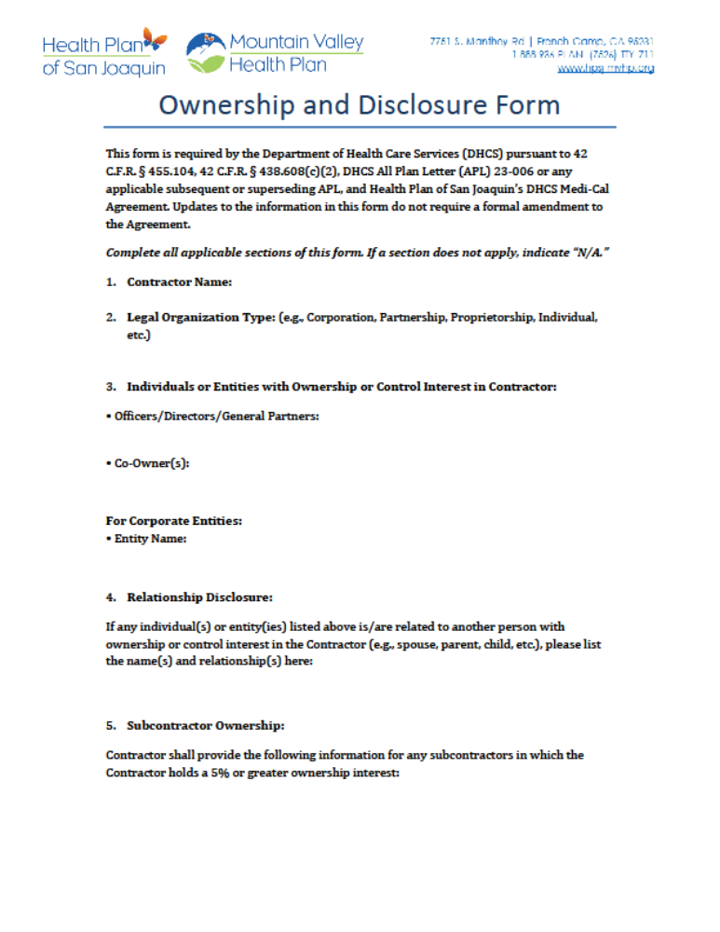

ATTACHMENT E - THIRD-PARTY ATTESTATION FORM (May be required at contracting phase)
(Provided for informational purposes only)
CONTRACTOR SUBCONTRACTS WITH A DOWNSTREAM CONTRACTOR TO PERFORM SERVICES SPECIFIED IN THE AGREEMENT BETWEEN CONTRACTOR AND HPSJ/MVHP
On behalf of San Joaquin County Health Commission ("Commission"), operating and doing business as Health Plan of San Joaquin and Mountain Valley Health Plan ("HPSJ/MVHP"), ​Click or tap here to enter text.​ (“Contractor”), a first-tier contractor of HPSJ, is providing information and supporting documents (“Contractor Materials”) to attest Contractor’s adherence to the Department of Health Care Services (DHCS) contractual requirements and all applicable laws and regulations when the Contractor subcontracts with Downstream Contractors¹ to perform services specified (“Services”) in the Agreements between Contractor and HPSJ/MVHP (“Agreements”). The Contractor is also providing Contractor Materials to attest that all Services delegated to the Downstream Contractor adhere to the same or stricter Service Level Agreement outlined in the Agreements.
The Contractor is providing the below Contractor Materials to support this attestation.
Contractor Materials:
- [Insert document name]
- [Insert document name]
By signing this Attestation Form, Contractor represents, warrants, and attests that the attached Contractor materials comply with all federal and state laws, regulations, and guidance, and contractual requirements as set forth in the Medi-Cal managed care contract between the DHCS and HPSJ/MVHP (“Contract”). Contractor also certifies that the attached Contractor materials are complete, accurate, and truthful based upon Contractor’s best information, knowledge and belief after making a diligent and thorough search and review of all records and information within Contractor’s control.
This Attestation Form must be completed by the Chief Executive officer (CEO), Chief Operating Officer (COO), or Compliance Officer (CO), or an individual who reports directly to the CEO with delegated authority to sign for the CEO, so that the CEO is ultimately responsible for the Attestation Form. Contractor must submit this Attestation Form whenever Contractor enters into a contractual relationship with a Downstream Contractor performing Services, and Contractor must attach all Contractor Materials to this Attestation Form.
Contractor retains full legal responsibility for the use of the attached Contractor Materials and agrees to indemnify and hold harmless HPSJ/MVHP, the State of California, DHCS, and their officers, agents, employees, control agencies, and other state agencies for any and all claims, losses, injuries, damages, attorneys’ fees and costs, and judgments resulting from the use of the attached Contractor Materials. Contractor also agrees and acknowledges to abide by all other indemnification provisions contained in the Contract with DHCS.
Contractor acknowledges HPSJ/MVHP and DHCS retain all of their rights under the Contract, including but not limited to, its right to review, modify, stop, approve, or deny the Contractor’s right to use the attached Contractor Materials. Alternatively, Contractor acknowledges HPSJ/MVHP and DHCS’ right to require Contractor to edit the Contractor Materials at any time.
Attestation
I hereby attest on behalf of ________________ that it has complied with and will continue to comply with all requirements set forth above.
Signature |  | Date Signed
Name of CEO, COO, or Compliance Officer)
(Printed Name of Contractor)
(City, State)

The following shall have the same legal force and effect as an original of the signed Attestation Form: a facsimile, photocopy, imaged or other electronic version.

ATTACHMENT F – NON-COLLUSION DECLARATION (Required for Public Works Projects Only)
Public Contract Code § 7106
State of California
County of Click or tap here to enter text.
The undersigned declares:
I am the Click or tap here to enter text. of Click or tap here to enter text., the party making the foregoing bid.
The bid is not made in the interest of, or on behalf of, any undisclosed person, partnership, company, association, organization, or corporation. The bid is genuine and not collusive or sham. The bidder has not directly or indirectly induced or solicited any other bidder to put in a false or sham bid. The bidder has not directly or indirectly colluded, conspired, connived, or agreed with any bidder or anyone else to put in a sham bid, or to refrain from bidding. The bidder has not in any manner, directly or indirectly, sought by agreement, communication, or conference with anyone to fix the bid price of the bidder or any other bidder, or to fix any overhead, profit, or cost element of the bid price, or that of any other bidder.
All statements contained in the bid are true. The bidder has not, directly or indirectly, submitted his or her bid price or any breakdown thereof, or the contents thereof, or divulged information or data relative thereto, to any corporation, partnership, company, association, organization, bid depository, or to any member or agent thereof, to effectuate a collusive or sham bid, and has not paid, and will not pay, any per son or entity for such purpose.
Any person executing this declaration on behalf of a bidder that is a corporation, partnership, joint venture, limited liability company, limited liability partnership, or any other entity, hereby represents that he or she has full power to execute, and does execute, this declaration on behalf of the bidder.
I declare under penalty of perjury under the laws of the State of California that the foregoing is true and correct, and that this declaration is executed on Click or tap here to enter date, at Click or tap her to enter City, Click or tap here to enter State.”

________________________________________
Signature

____________________
Date

ATTACHMENT G – OFFSHORING QUESTIONAIRRE (Required with Submission)
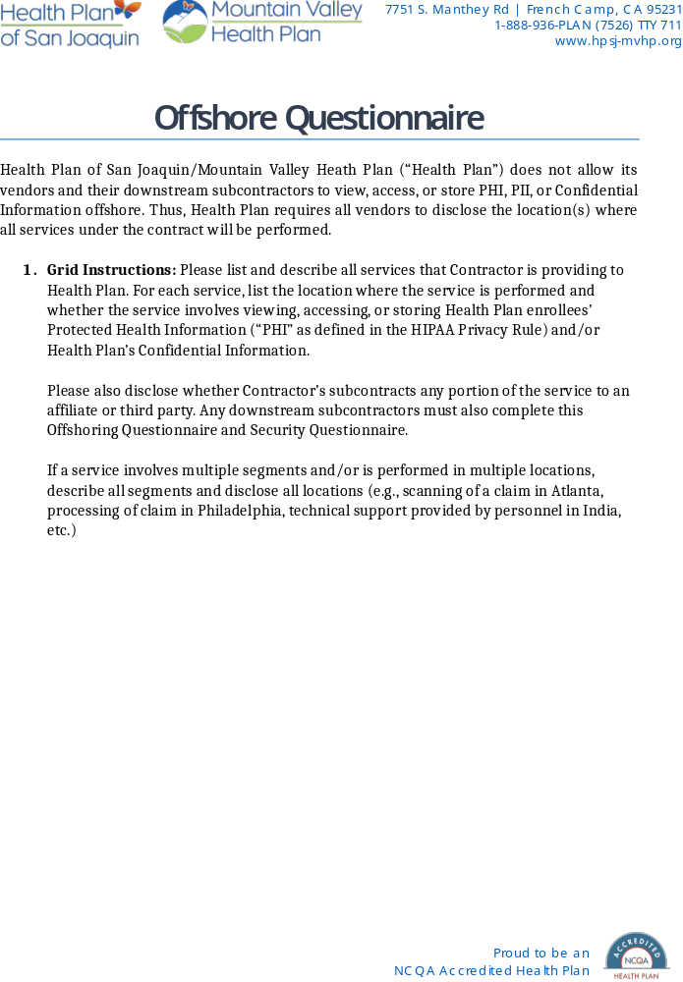

ATTACHMENT H – CONFLICT OF INTEREST (Required with Submission)
Instructions: Double click the form to access.
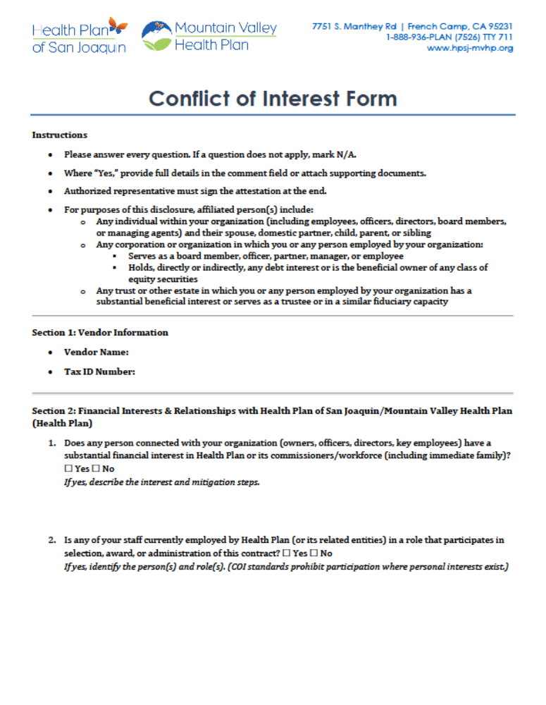

ATTACHMENT I – BIDDER RESPONSIBILITY AND CERTIFICATION (Required with Submission)
The Bidder certifies, to the best of its knowledge and belief, that the Bidder and any of its Principals:
A. Are ☐, are not ☐ currently debarred, suspended, proposed for debarment, or otherwise declared ineligible by any Federal agency, or prohibited from participating in any Federal healthcare program. (If “are,” please explain:) Click or tap here to enter text.

B. Have ☐, have not ☐ been convicted of, or had a civil judgment entered against them within the past ten (10) years for any of the following:
• fraud or a criminal offense related to obtaining, attempting to obtain, or performing a public contract;
• violations of Federal or State antitrust laws related to submitting offers;
• embezzlement, theft, forgery, bribery, falsification or destruction of records, making false statements, tax evasion, violations of Federal criminal tax laws, or receipt of stolen property.
(If “have,” please explain:) Click or tap here to enter text.

C. Are ☐, are not ☐ currently indicted or otherwise charged (criminally or civilly) by a governmental entity for any of the offenses listed in Section B. (If “are,” please explain:)
Click or tap here to enter text.
D. Have ☐, have not ☐ been notified within the past ten (10) years of any unpaid Federal tax liability exceeding $3,000 that remains unresolved. (If “have,” please explain:) Click or tap here to enter text.
E. Have ☐, have not ☐ experienced a data security incident, cybersecurity breach, unauthorized access event, ransomware attack, or similar security compromise within the past ten (10) years.
If “have,” please provide:
- A brief description of the incident;
- The cause or contributing factors;
- The corrective and remediation actions taken;
- Any steps implemented to prevent future occurrences.
Explanation: Click or tap here to enter text.
Note: Disclosure of past incidents, including security breaches or other issues listed above, will not result in automatic disqualification. Information provided will be evaluated to assess the Bidder’s responsibility, transparency, and remediation efforts.
For the purpose of this certification, “Principal” includes an officer, director, owner, partner, or any individual with primary management or supervisory authority within the organization (for example, a general manager, division head, or similar position).

By:
Name: Click or tap here to enter text.
Title: Click or tap here to enter text.
Company: Click or tap here to enter text.
Date: Click or tap here to enter text.

ATTACHMENT J – PROPOSAL SIGNATURE VERIFICATION (Required with Submission)
All proposals submitted in response to this RFP must be received no later than Wednesday, 6/24/2026, by 2:00 PM PST at procurement@hpsj.com
All submissions are governed by the Instructions and Conditions, general provisions, special provisions, and all Attachments included with this RFP.
By signing below, the Bidder confirms that, if its proposal is accepted—either in full or in part—it agrees to furnish the products, materials, and/or services described in the Attachments in accordance with:
- the terms of this RFP,
- the applicable contract executed between the parties, and
- any governing master agreements between Health Plan and the State of California.

Bidder Organizational Name: Click or tap here to enter text.
Address: Click or tap here to enter text.
Phone Number: Click or tap here to enter text.

Printed Name and Title of Authorized Representative:Click or tap here to enter text.

Signature of Authorized Representative (please use Docusign or similar):

__________________________________________

Date of Proposal Submission: Click or tap here to enter text.

Total Amount from “Attachment B”: $ Click or tap here to enter text.

Acknowledgment of Amendments
The Bidder acknowledges receipt of the following RFP Amendments (if applicable):
Amendment # | Amendment Date | Amendment # | Amendment Date
Click or tap here to enter text. | Click or tap here to enter text. | Click or tap here to enter text. | Click or tap here to enter text.
Click or tap here to enter text. | Click or tap here to enter text. | Click or tap here to enter text. | Click or tap here to enter text.
Click or tap here to enter text. | Click or tap here to enter text. | Click or tap here to enter text. | Click or tap here to enter text.

