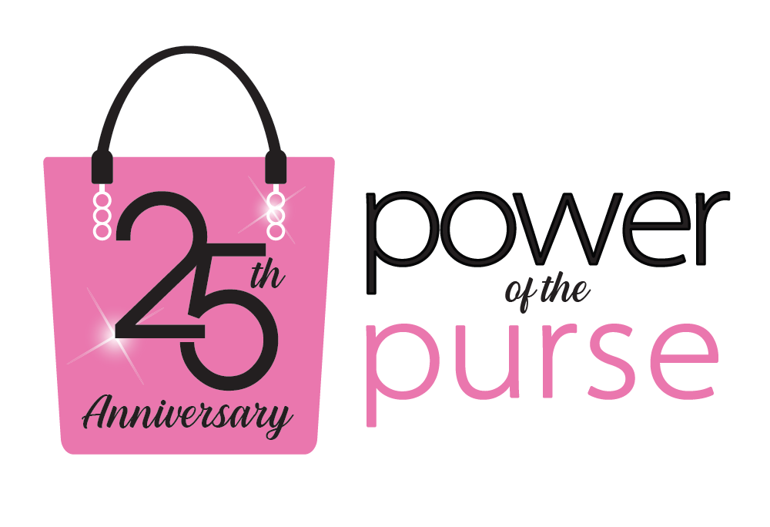
Join us on October 25, 2022, at the Gallo Center for the Arts to celebrate the 25th anniversary of the Power of the Purse event.

Please visit uwaystan.org/power-of-the-purse to register for the event.

Purse Raffle Tickets: $20 for 5 Tickets (over $250 value per purse)
Mystery Purse Raffle Ticket: $20 per ticket (over $1500 value)

For more information or to purchase raffle tickets, please contact Habiba Rani at
209-718-7069 or email hrani@uwaystan.org.

